[title]

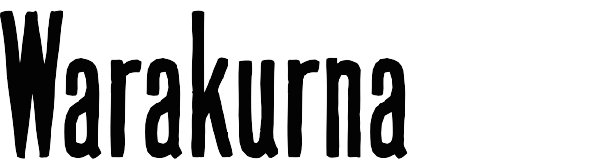

**Curriculum mapping | Year 1**

|  |  |  |
| --- | --- | --- |
| **Australian Curriculum Version 9**  **Aboriginal and Torres Strait Islander Histories and Cultures**  Country/ Place A_TSICP1  English | **Warakurna education resources**  [**https://digital-classroom.nma.gov.au/warakurna**](https://digital-classroom.nma.gov.au/warakurna) | **Warakurna activity booklet** |
| **AC9E1LA08**  Compare how images in different types of texts contribute to meaning. | * Flip book * Teacher guide * Videos | * Student activity booklet * Discussions |
| **Elaborations**  Explore images in stories and cultural accounts by First Nations Australian authors and discuss the impact this may have. | * Flip book * Teacher guide * Videos | * Student activity booklet * Discussions |
| **AC9E1LE01**  Discuss how language and images are used to create characters, settings and events in literature by First Nations Australian, and wide-ranging Australian and world authors and illustrators. | * Flip book * Teacher guide * Videos | * Student activity booklet * Discussions |
| **Elaborations**  Discuss how characters, settings and events are described or depicted in literature by First Nations Australian authors and illustrators. | * Flip book * Teacher guide * Videos | * Student activity booklet * Discussions |
| **Visual Arts Year 1–2 AC9AVA2E01**  Explore where, why and how people across cultures, communities and/or other contexts experience visual arts. | * Flip book * Teacher guide * Videos | * Student activity booklet * Discussions |

|  |  |  |
| --- | --- | --- |
| **Visual Arts Year 1–2 AC9AVA2E02**  Explore examples of visual arts created by First Nations Australians. | * Flip book * Teacher guide * Videos | * Student activity booklet * Discussions |