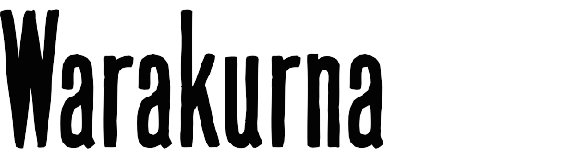
[title]

Curriculum mapping | Year 2

Australian Curriculum Version 9  Aboriginal and Torres Strait Islander Histories and Cultures  Country/Place A_TSICP1  English | Warakurna education resources  https://digital-classroom.nma.gov.au/warakurna | Warakurna activity booklet
AC9E2LE01 | - Flip book | - Q1
Discuss how characters and settings are connected in literature created by First Nations Australian, and wide-ranging Australian and world authors and illustrators. |  | - Q2  - Q3
AC9E2LA01 | - Flip book | - Q4
Investigate how interpersonal language choices vary depending on the context, including the |  | - Q5
different roles taken on in interactions.
Elaborations  Explore First Nations Australian cultural protocols in Welcome to Country and Acknowledgement of Country, and the greeting words used by local First Nations Australians. | - Flip book | - Q6
English Year 2
- Language
AC9E2LA10  Recognise that capital letters are used in titles and commas are used to separate items in lists. |  | - Q5

Experiment with and begin to make conscious choices of vocabulary to suit the topic. |  | - Artwork
AC9E2LA09 |  | - Q4
 |  | - Q5
Aboriginal and Torres Strait Islander Histories and Cultures |  | - Artwork
Culture |  | - Q4  - Q5
First Nations Australian societies are diverse and have distinct cultural expressions such as language, customs and beliefs. As First Nations Peoples of Australia, they have the right to maintain, control, protect and develop their cultural expressions, while also maintaining the right |  | - Q6  - Q7
to control, protect and develop culture as Indigenous Cultural and Intellectual Property.
Visual arts
Exploring and responding
AC9AVA2E01 | - Flip book | - Q1
Explore where, why and how people across cultures, communities and/or other contexts experience visual arts. | - Artworks  - Artists | - Q2  - Q3  - Q4
AC9AVA2E02 | - Flip book | - Q1
Explore examples of visual arts created by First Nations Australians. | - Artworks  - Artists | - Q2  - Q3
 |  | - Q4

