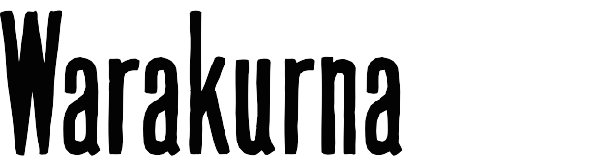
[title]

Curriculum mapping | Year 3

Australian Curriculum Version 9  Aboriginal and Torres Strait Islander Histories and Cultures  Country/Place A_TSICP1  English | Warakurna education resources  https://digital-classroom.nma.gov.au/warakurna | Warakurna activity booklet
AC9E3LE01 | - Digital flip book | - Q1
Discuss characters, events and settings in different contexts in literature by First Nations | - Videos | - Q2
Australian, and wide-ranging Australian and world authors and illustrators.
Elaborations | - Digital flip book | - Q2
Discuss characters and their relationship with Country/Place and families in literature by First | - Videos | - Q3
Nations Australian authors.
Visual Arts
Exploring and responding
AC9AVA4E01 | - Digital flip book | - Q1
Explore where, why and how visual arts are created and/or presented across cultures, times, places and/or other contexts. | - Videos  - Artworks  - Artists | - Q3

AC9AVA4E02 | - Digital flip book | - Q1
Explore how First Nations Australians use visual arts to communicate their connection to and responsibility for Country/Place. | - Videos  - Artworks  - Artists | - Q2  - Q3  - Q4
 |  | - Q5
 |  | - Q6
Developing practices and skills
AC9AVA4D01 | - Games | - Q5
Experiment with a range of ways to use visual conventions, visual arts processes and materials. |  | - Q6
Creating and making
AC9AVA4C01 | - Games | - Q5
Use visual conventions, visual arts processes and materials to create artworks that communicate |  | - Q6
ideas, perspectives and/or meaning.

