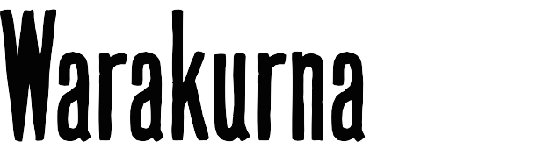
[title]

Curriculum mapping | Year 6

Australian Curriculum Version 9  Aboriginal and Torres Strait Islander Histories and Cultures  Country/Place A_TSICP1  English | Warakurna education resources  https://digital-classroom.nma.gov.au/warakurna | Warakurna activity booklet
AC9E6LE04  Explain the way authors use sound and imagery to create meaning and effect in poetry. | - Watch videos  - Artworks section  - Digital flip book | - See elaboration
Elaborations  Identify the imagery used in narratives or poetry about First Nations Australians’ Country/Place. | - Watch videos  - Artworks section  - Digital flip book | - Student activity booklet
AC9E6LE03  Identify and explain characteristics that define an author’s individual style. | - Watch videos  - Digital flip book  - Artworks section  - Artist section | - Student activity booklet
Elaborations  Focus on a First Nations Australian author and identify characteristic elements of their writing; for example, images, theme and language. | - Watch videos  - Digital flip book  - Artworks section  - Artist section | - Student activity booklet

AC9E6LE01  Identify responses to characters and events in literary texts, drawn from historical, social or cultural contexts, by First Nations Australian, and wide-ranging Australian and world authors. | - Watch videos  - Digital flip book  - Artworks section  - Artist section | - Student activity booklet
AC9AVA6E01  Explore ways that visual conventions, visual arts processes and materials are combined to communicate ideas, perspectives and/or meaning in visual arts across cultures, times, places and/or other contexts. | - About page  - Watch videos  - Digital flip book  - Artwork section  - Artist section | - Student activity booklet
Elaborations  Use viewpoints to develop questions to examine, compare and contrast what they notice in artwork: for example, as a class, critically navigate multiple perspectives of the same artwork and question why they see these works differently. | - About page  - Watch videos  - Digital flip book  - Artwork section  - Artist section | - Student activity booklet
AC9AVA6E02  Explore ways that First Nations Australians use visual arts to continue and revitalise cultures. | - About page  - Watch videos  - Digital flip book  - Artwork section  - Artist section | - Student activity booklet

