Resources: https://digital-classroom.nma.gov.au/warakurna
This activity requires you to choose a special or favourite place in your aerial artwork from your activity sheets and create a treasure hunt or journey leading your peers with clues. Follow the instructions below to begin your game.

Student activity | Group art and grid activity

- After completing an aerial artwork from your activity sheet make a copy of your artwork. This could be done by taking a photo and printing it, scanning with a photocopy machine, or printing the copy out onto another piece of paper.

- The next step is to create a grid to overlay onto your artwork. It can be large squares, making your grid minimal with fewer coordinates, or smaller squares, making your grid larger with more coordinates.
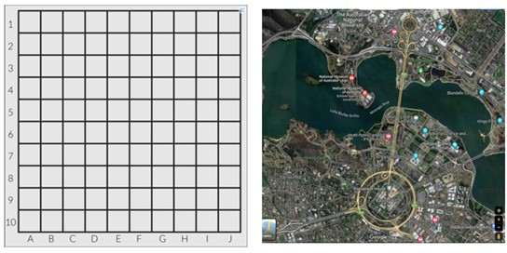
- Place the grid over your artwork copy.

Below is an example of the National Museum of Australia and a satellite picture from Google maps.
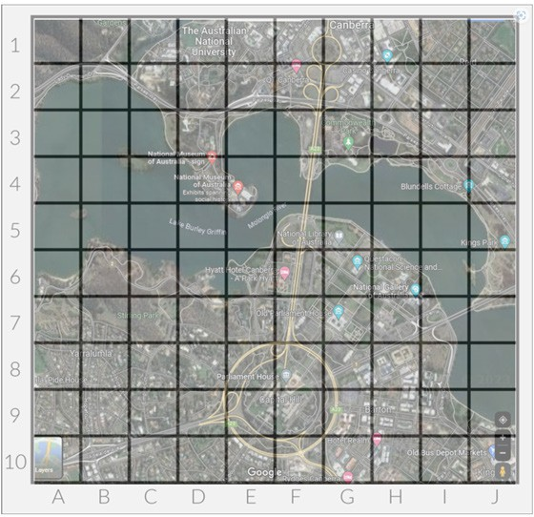

- Once you have overlaid a grid image onto your artwork create coordinates with clues to lead your viewers or players to your special or favourite location in your artwork. When creating your questions to reveal coordinates ensure the below points are addressed:
  - Your coordinates must reveal interesting facts about your artwork.
  - Once players have joined the coordinates together it will create a journey line revealing your special or favourite location.
  - When you reveal your location provide the reasoning behind the unique characters that make.

For example:

Aerial artwork treasure hunt

By answering the questions below, find the coordinates and join each one with a journey line. Find the special location and research its importance.

- Australia and its government’s decisions are being discussed in this location
Answer: F8, Parliament House
- Follow the structure that which carries a road and path across the water.
Answer: F7, F6, F5, F4, F3 Bridge
- Move to the central part or main business and commercial area of Canberra
Answer: FG1
- This landform is almost surrounded by water or projecting out into a body of water.

Answer: E4
- Location coordinate:
Hint: My special location is where stories come alive

- With your class or group discuss what makes a place special and compare ideas on why you think the artists from Warakurna chose to paint the locations displayed in the flip book. Artwork recommendations to discuss.

  - Page 6: Warakurna Community, 2011, Artist – Tracy Yates
  - Page 10: Holiday Time, 2011, Artist – Eunice Yunurupa Porter
  - Page 12: Going Home, 2011, Artist – Eunice Yunurupa Porter
  - Page 14: Helicopter Ride with Brooksy to See My Father’s Ngurra (Country), 2011 – Artist Ken Shepherd
  - Page 20: Tjanpi, 2011, Artist – Polly Pawuya Butler-Jackson
  - Page 22: Land Management Burning Country, 2012 – Artist Dianne Ungukalpi Golding

