- View the Warakurna resources listed below and take notes on how these sources of information regarding the same imagery can have a different effect on how you understand or feel about those images.

Student activity booklet | Year 6

Resources:

  - About page
  - Digital flip book
  - Artworks
  - Artists
  - Audio and videos

Points to consider when taking notes:

  - Which resource gave you more knowledge and why?

  - What characteristics/images in your favourite artwork created the most impact by expressing individuality?

- Choose an artwork from the Warakurna artworks section and write about this artwork.

  - How did the artwork create a deeper understanding of First Nations connection to Country or place for you?

  - How did the artwork present a style that was unique and how did this style impact your emotions or point of view?

  - How did the artwork show characters who played a major role in the storyline of the artwork?

  - Do you think that creating artworks like the one you have chosen keeps First Nations culture alive? If so, why?

Example:
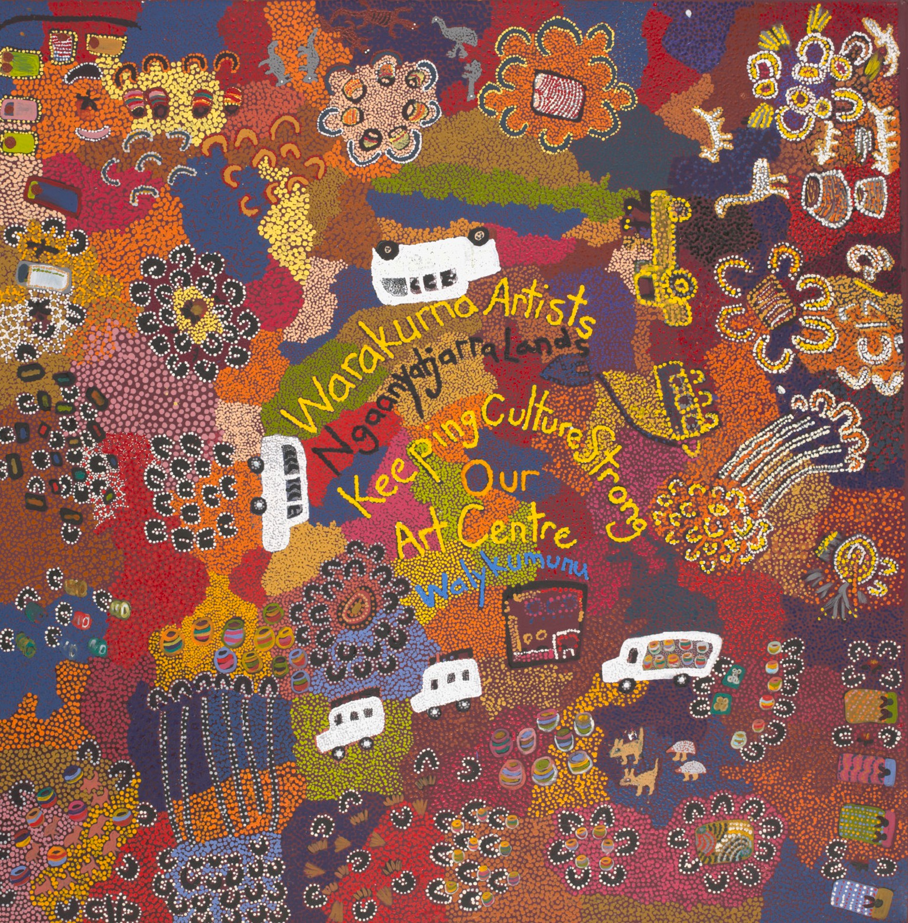
Artwork: Keeping Culture Strong, 2008, was painted by six artists.
Artists: Eunice Yunurupa Porter, Molly Malungka Yates, Judith Yinyika Chambers, Anna Porter, Maisie Nungurrayi Ward and Polly Pawuya Butler-Jackson.

This artwork created a great understanding for me on how many people made up the community. All people were interacting with one another in different ways. I could see many activities on Country.

The sleeping bags helped me understand that they could stay overnight for a long time on Country. It feels like a special place.

All the different colours made me feel warmth and made it seem that there were different parts of the Country.

I feel as though the cars were very important and this made it feel as if there was a lot of travel at a lot of distances. I like how the cars are not on roads.

- Watch both parts of the Video 3 – National Museum art activity and in a group, complete an aerial view artwork of your town or a region of your city.
Your artwork must display a historical or social event that has impacted your chosen location. Write a description of your artwork explaining the key images in your artwork that are historical or social.

Points to consider when creating your artwork:

  - Images used
  - Themes of events or era/time
  - Language and words you may place in your artwork to support a theme, place or era/time.

