Resources: https://digital-classroom.nma.gov.au/warakurna
Artwork:

Student activity booklet | Year 2
Keeping Culture Strong, 2008
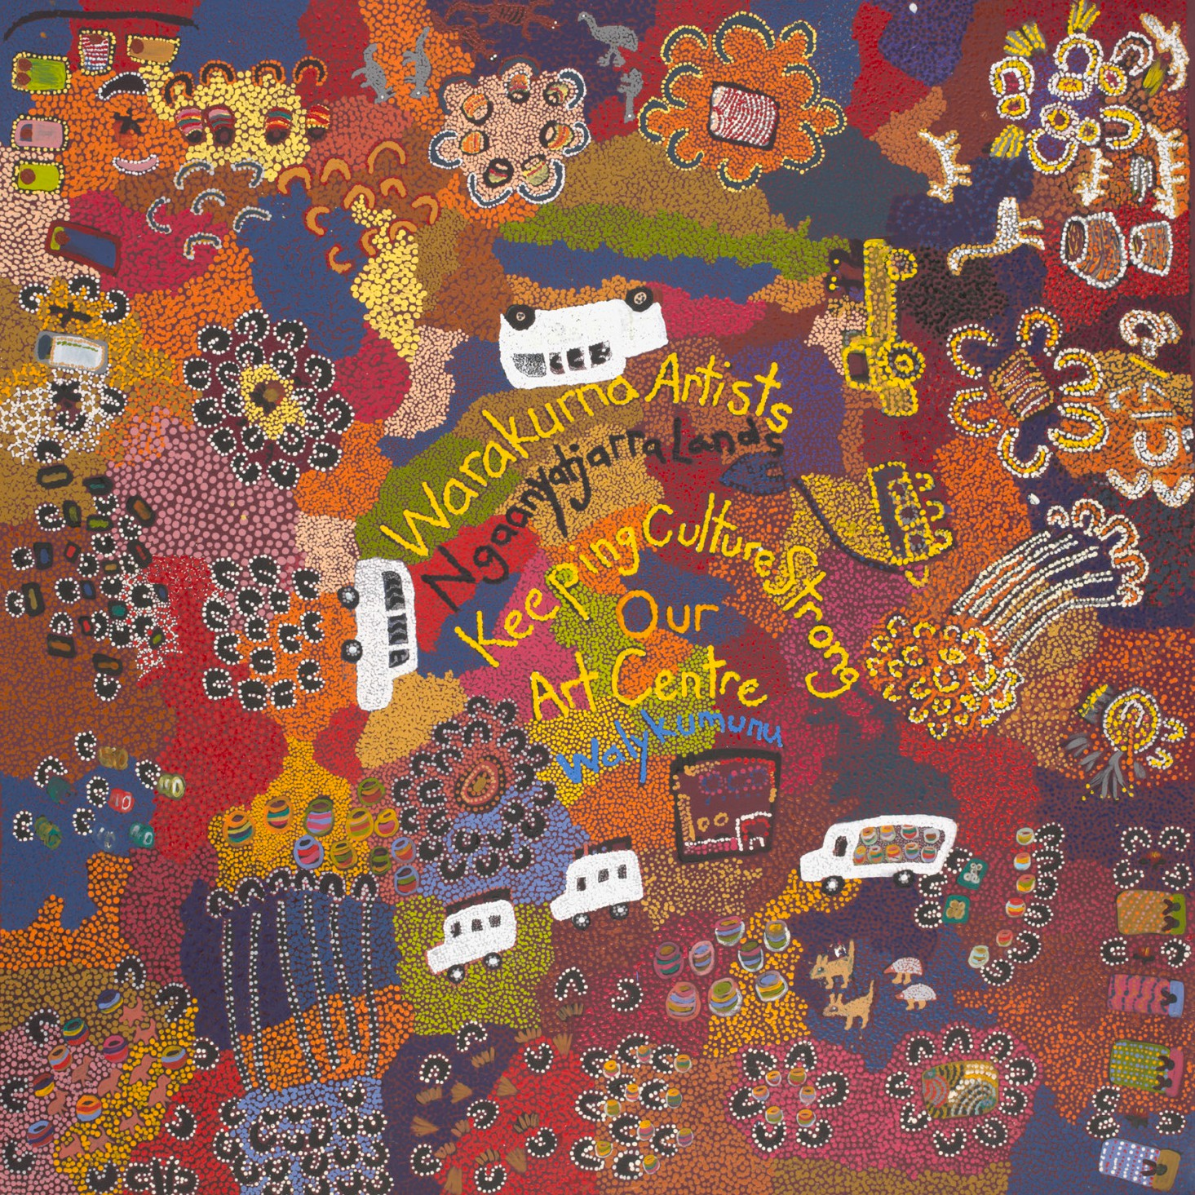

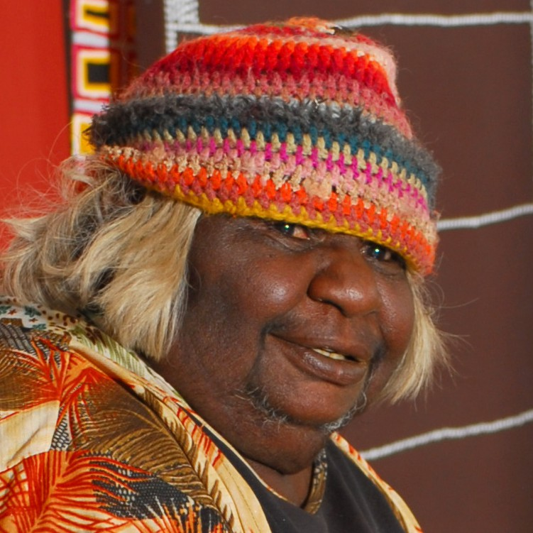
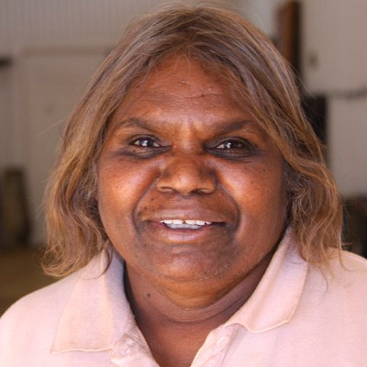
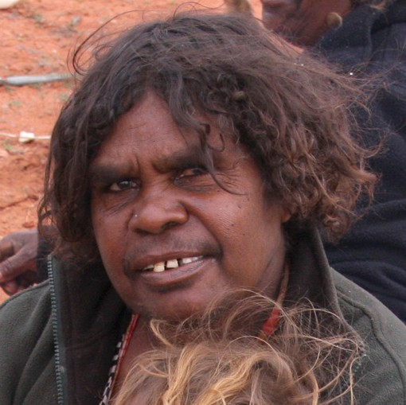
Artists
Eunice Yunurupa Porter
Judith Yinyika Chambers
Polly Pawuya Butler-Jackson
Photos unavailable: Molly Malungka Yates, Anna Porter and Maisie Nungurrayi Ward

- Look at the artwork Keeping Culture Strong. You can also view the artwork in the digital flip book.

- Write down the different objects that you can see.

- Talk with your class group about the different objects that you found in the painting that tell the story of the community.

- In a group draw a bird’s eye view of your community. Imagine you are all in a plane, looking over your community.

- Think and talk about what landmarks and objects you can see from the plane and draw these objects in your artwork together.

  - What landmarks are important?

  - What season is it, and how does it change the colour of an artwork?

  - What natural landscape or man-made areas will be in your drawing?

  - Write down some of the names of the special places you have drawn.

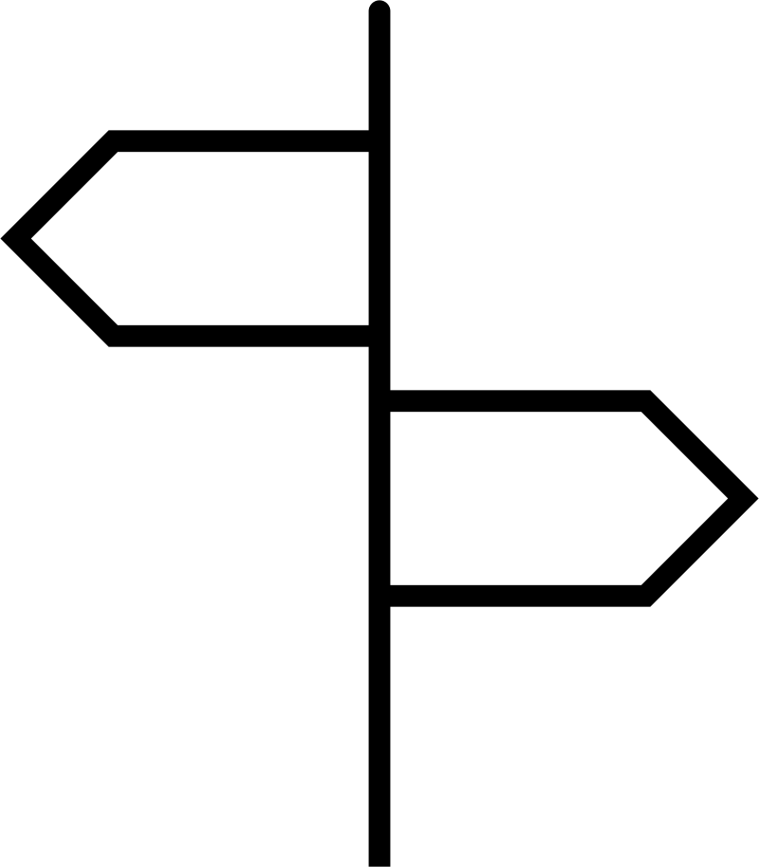
- Once you have completed your artwork as a group, write the First Nations name of the Country you have drawn. Make sure you place a capital letter on name as it is a title.

Talk about what the word means, and why you think it was called this.

- There are many other First Nation names for different regions in Australia. Many of Australian streets are named with First Nation words. Is there are street in your artwork that uses First Nations language? If so, draw it on a street sign in your artwork. If not do you know a First Nations word that you could use to name a street?

- It is respectful to acknowledge the First Nations land you live on. Do you know how to do an Acknowledgement of Country? Write down some words as a group that you think would be in an Acknowledgement of Country.

