Student activity booklet | Year 3

Resources: https://digital-classroom.nma.gov.au/warakurna

- Watch both parts of video 3, and video 4, discussing the points below as a group.
  - What are the different meanings of the words ochre and soil?

  - Discuss why you think ochre is different?

  - Do First Nations people only tell stories written on the ground?

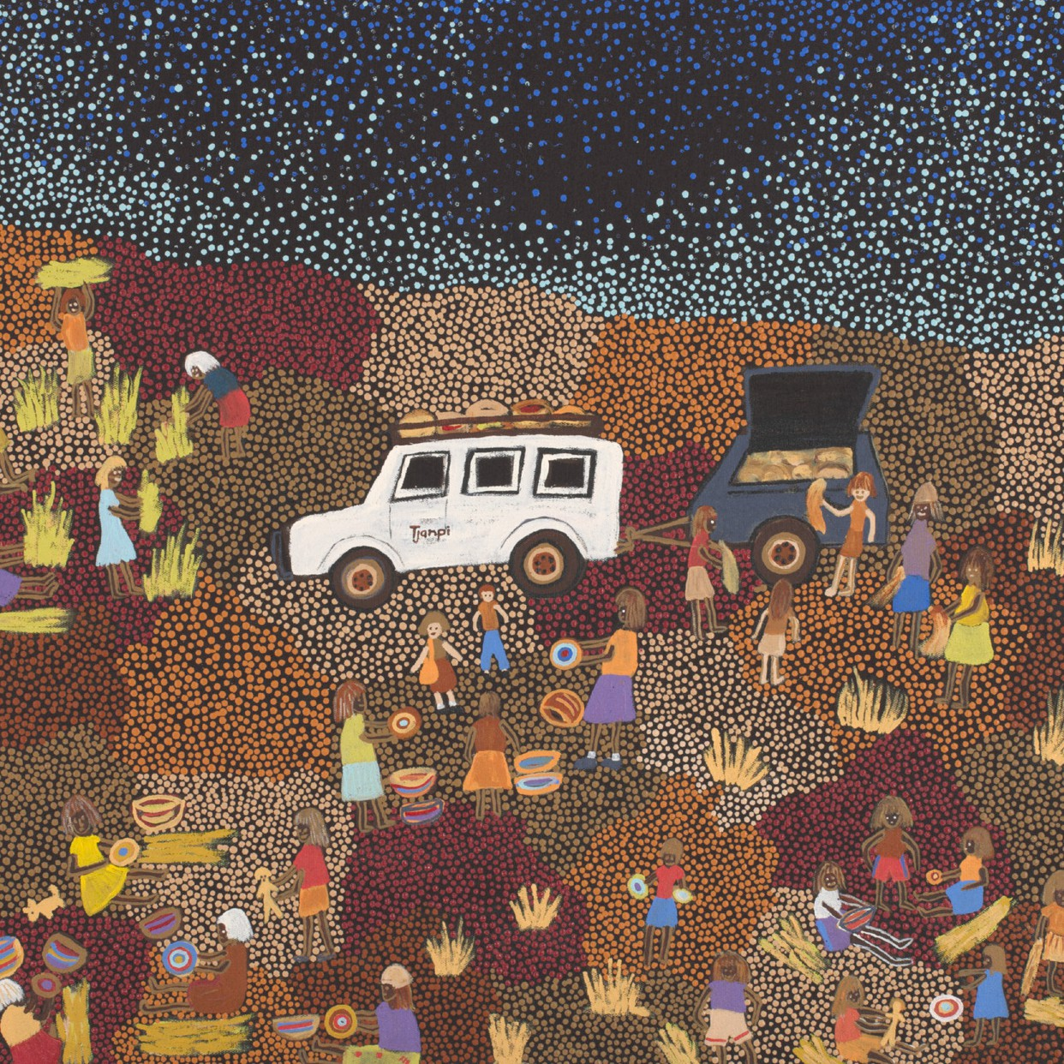
Artwork: Tjanpi, 2011 Artist: Polly Pawuya Butler-Jackson

- As a group discuss the artwork Tjanpi from the Warakurna digital flip book.

  - Discuss why you think it is painted in this landscape view with the ground and night sky.

  - Discuss the name of the artwork and what it means.

  - What objects are in the artwork?

  - What characters are in the artwork?

  - What do you think the characters are doing?

  - What relationship do you think the artist has with the Country? Explain why you think this.

- As a group, select an artwork from the Warakurna digital flip book which shows an aerial view.

  - What do you think an aerial view is?

  - Discuss why you think the artwork you have chosen is painted in an aerial view.

  - What relationship do you think the artist has with the Country? Explain why you think this.

  - What objects are in the artwork?

  - What characters are in the artwork?

  - What do you think the characters are doing?

- Play the ‘Up, down and move around’ game in your school playground. When you have finished playing the game, draw your favourite place or object in the playground.

- In a group, draw or paint an aerial view of your school with key characters playing out an activity. Draw or paint special landmarks, buildings and objects. Be sure to draw or paint your favourite thing from the game in this artwork.

