Student activity booklet | Year 4

Resources: https://digital-classroom.nma.gov.au/warakurna

- In a group read through the digital flip book and choose two artworks which are similar. Once you have chosen your artworks, explain to your class why you think they are similar. Suggestions for similarities could be:

  - activities be carried out
  - the artist descriptions
  - colours being used
  - patterns or symbols used
  - words used.

Artwork 1

Artwork 2

- Watch both parts of video 3, and video 4, and discuss the points below as a group.

What are the different meanings of the words ochre and soil.

Discuss why you think ochre is different from soil?

What do First Nations people use ochre for?

- Research ochre and discuss one image you have found that tells you a little more about ochre and how it is used. Reference where you found this information and present to your class.

Print an image of ochre and place here!

Where did you find this image?

- Part 1

Research a First Nations poet and look at the words they use to help you imagine and feel what they are saying.

First Nations poet:

The poem they wrote:

Words you like in the poem:

Part 2

Choose one of the below artworks from the Warakurna digital flip book and write a poem about how it makes you feel.

Artwork 1 Artwork 2
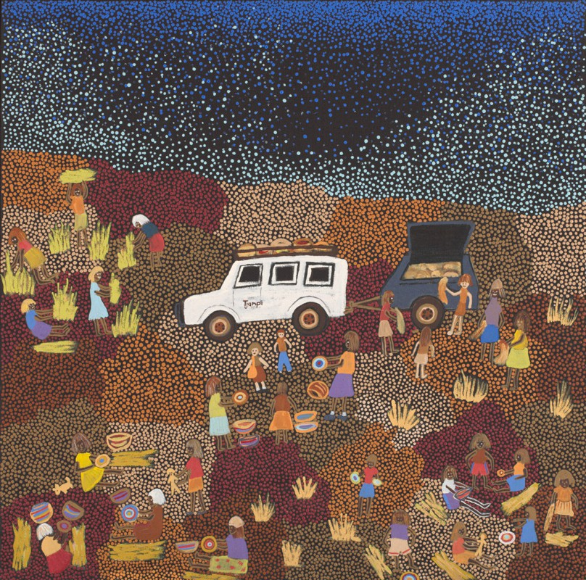
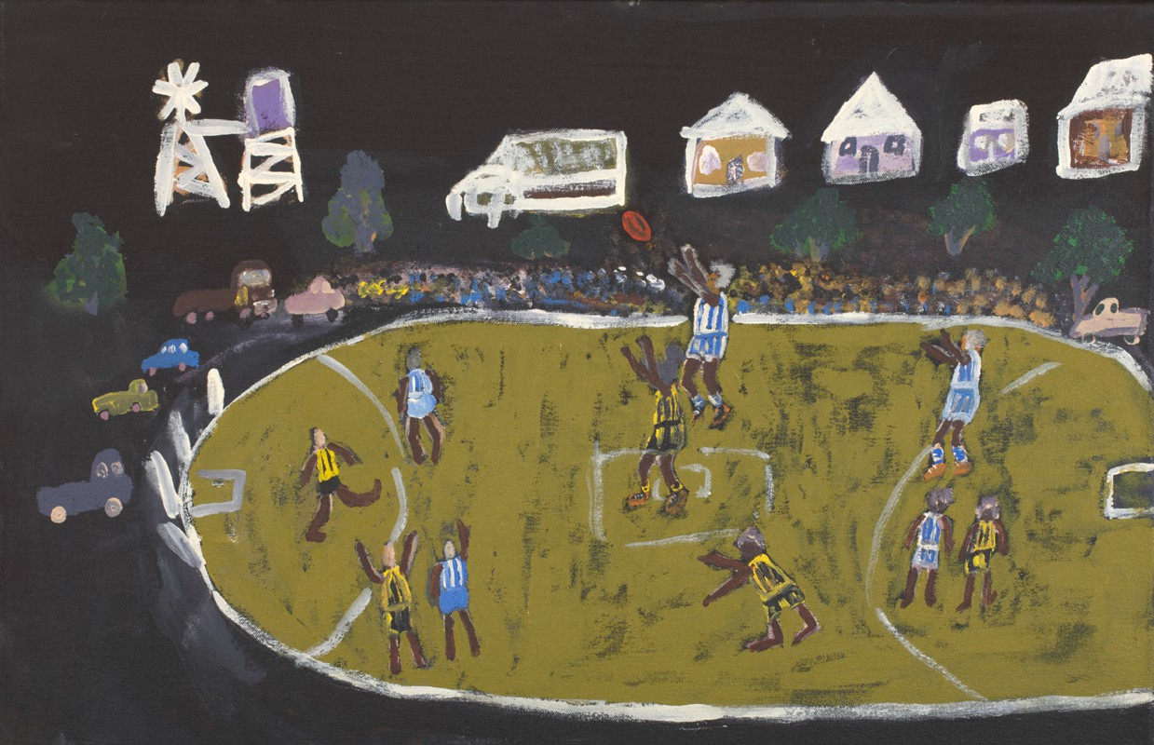
- Artwork 1 name: Tjanpi, 2011 Artist: Polly Pawuya Butler-Jackson
- Artwork 2 name: Warakurna Kangaroos and Warburton Tigers, 2012 Artist: Rocky Porter

My poem and First Nations art

- Play the ‘Up, down and move around’ game outside in your school playground. Remember one word of an object, landmark, building or feeling that you experienced in this game.

Write your word down here:

- In a group draw or paint an aerial view of your school playground with key characters playing out an activity. Write a short poem together that accompanies your artwork.
Note: You must use the one word you collected from your game in this poem. The other players in your group must also use the words they saved in this game.

For example:
Alice’s word – grass. Charles’s word – running.

Group poem:
We love running fast on the playground grass.

