Teacher guide: grid game | Year 6

LESSON PREPARATION | First Nations students are recommended to consult with and seek permission from Elders before detailing their artwork. This will require teachers to plan discussions before creating artworks. Explain the activity to students and encourage them to discuss with family members the night before the activity is to be completed. View the full Warakurna resource on the Digital Classroom website.  This activity requires your students to choose a special or favourite place in their aerial artwork from provided activity sheets and create a treasure hunt or journey leading their class colleagues with clues. Follow the instructions below to begin creating the treasure hunt game.
DISCUSSING THE ARTWORK AND CULTURAL  CONSIDERATIONS | In your activity you are asked to make a copy of an aerial artwork and place a grid over the top of the artwork.  Be mindful that First Nations students may be hesitant but reassure students that the objective of the game is to make note of unique objects or places in artwork and that they can take the original artwork home with them. If there is still resistance, encourage a new artwork that is of school and not a personal landmark.  There are multiple questions provided below which help create understanding of cultural expressions to support all modes of delivery. These questions will guide your delivery and support your participants in understanding cultural views of Aboriginal and Torres Strait Islander peoples.  Cultural guidance:  When asking about First Nations symbols in artworks, discuss the cultural significance of Aboriginal symbols and how these symbols originated in Aboriginal artworks. The Aboriginal symbols in this artwork represent Elders doing ceremonies. Ensure students understand that they are Aboriginal interpretations of their Elders and family traditions and ask students how they would represent themselves in their artworks if they were not First Nations people. Ensure you are aware of your students who are First Nations people and provide a safe sharing space that individuals feel confident to express themselves in. Be mindful that not all First Nations people know cultural protocols and symbol origination. Some art styles are owned by certain family groups.
ARTWORK TITLE | Aerial artwork
ARTIST | Student
ARTWORK IMAGE | Photocopy or make a copy of artwork to place grid on

WHAT IS IMPORTANT ABOUT THIS ARTWORK | - An aerial view has been a cultural interpretation and popular style for many Aboriginal and Torres Strait Islander artists. It often relates to Dreaming information which can be overlaid on landscape. This overlay can be physical and spiritual.  - The activities are strongly associated to the Country and are hands-on in focus. This depicts a strong connection to the location and the relationships between people.  - Patterns and/or symbols of Aboriginal and Torres Strait Islander art are a continuation of important cultural stories passed down through generations. It has been a way of storytelling for many years. The use of these patterns or symbols can be seen as an alternative way of writing down stories. Only First Nations people can use these for storytelling.
ACTIVITY OBJECTIVE | - Use Warakurna resources and discuss artworks and games.  - Have discussions by asking diverse questions to build cultural understanding.  - Create an artwork to strengthen own knowledge and to build a visual and unique perspective.  - The grid creates a new way of looking at own artwork of place.
DIRECTIONS, QUESTIONS AND IDEAS FOR DELIVERY | Step 1:  Create aerial artworks from activity sheets. This may be done in groups.  Step 2:  Create a copy of artwork. After completing an aerial artwork from provided activity sheet make a copy of all artworks. This could be done via taking a photo and printing it, scanning with a photocopy machine or printing the copy out onto another piece of paper.  Step 3:  Students choose favourite location or image in artwork. Ensure students have a good understanding of their choice.  Step 4:  Create a grid to overlay artwork copies. Students will have unique skills to complete a grid.  Note: The number of squares will relate to students’ skill set.  It can be large squares making your grid minimal with fewer coordinates, or smaller squares making your grid larger with more coordinates.  Step 5:  Place the grid over your artwork copy.  Step 6:  Set the number of questions to relate to your cohort.

EXAMPLE | Below is an example of the National Museum of Australia and a satellite picture from Google maps.  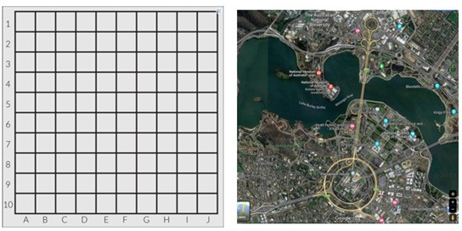  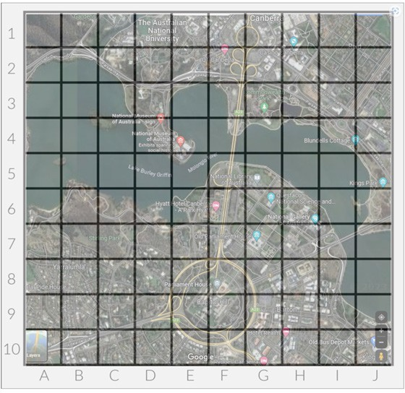

Aerial artwork treasure hunt
By answering the questions below, find the coordinates and join each coordinate with a journey line. Find the special location and research its importance.
- Q1: Australia and its government’s decisions are being discussed in this location.
Answer: F8, Parliament House
- Q2: Follow the structure that carries a road and path across the water.
Answer: F7, F6, F5, F4, F3 Bridge
- Q3: Move to the central part or main business and commercial area of Canberra.
Answer: FG1
- Q4: This landform is almost surrounded by water or projecting out into a body of water.
Answer: E4
Hint: My special location is where stories come alive
Location coordinate: the National Museum of Australia.
Create a safe environment where students can speak about their interpretation of the artwork and their grid questions ensuring that their hunt will lead to their special or favourite location.
Once completed ask students to swap grid artworks with other groups or individuals and play the treasure hunt game.
Final group activity:
With your class or groups, discuss what makes a place special and compare ideas on why you think the artists from Warakurna chose to paint these locations which are displayed in the flip book.

Artwork recommendations to discuss:
- Page 6: Warakurna Community, 2011, Artist, Tracy Yates
- Page 10: Holiday Time, 2011, Artist, Eunice Yunurupa Porter
- Page 12: Going Home, 2011, Artist, Eunice Yunurupa Porter
- Page 14: Helicopter Ride with Brooksy to See My Father’s Ngurra (Country), 2011, Artist Ken Shepherd
- Page 20: Tjanpi, 2011, Artist Polly Pawuya Butler-Jackson
- Page 22: Land Management Burning Country, 2012, Artist Dianne Ungukalpi Golding

Points to discuss:
- What makes a place special?
- What makes a place sacred?
- How long do you think First Nations people have been gathering in a location that is special to their family to make it sacred?
- Does your family have a special place where they gather more than once a year?
- If you spend a lot of time for many years at a location what do think you would learn from that Country or land?
- If your special place was no longer available to you to visit, how would you feel?
- What could you do to protect your special place?
- Would you share your special place with family or other people?
- Would you put something on your special place, such as a walking track, building, art or signs?
- What special objects or things have First Nations people put on their sacred locations?
COMPLETING ACTIVITY | - Complete aerial artwork.  - Make a copy of original artwork.  - Place grid over artwork.  - Set the number of questions to relate to your cohort.  - Question.  - Answer.

