[title]

Teacher guide | Year 2

LESSON PREPARATION | Explain the activity to students and encourage them to discuss with family members before undertaking it. Ensure that First Nations students consult with and seek permission from their Elders before drawing their special place.  View the full Warakurna resource on the Digital Classroom website.
DISCUSSING THE ARTWORK AND CULTURAL  CONSIDERATIONS | In your activity you are asked to discuss the below artwork. There are multiple questions provided which help create understanding of cultural expressions to support all modes of delivery. These questions will guide your delivery and support your participants in understanding cultural views of Aboriginal and Torres Strait Islander peoples.  Cultural guidance:  When asking about First Nations Symbols in artworks discuss the cultural significance of Aboriginal symbols and how these originated in Aboriginal artworks. The Aboriginal symbols in this artwork represent Elders doing ceremonies. Ensure students understand that they are Aboriginal interpretations of their Elders and family traditions and ask students how they would represent themselves in  their artworks if they are not First Nations people. Ensure you are aware of your students who are First Nations people and provide a safe sharing space that individuals feel confident to express themselves in. Be mindful that not all First Nations people know cultural protocols and symbol origination. Some art styles are owned by certain family groups.
ARTWORK TITLE | Keeping Culture Strong
ARTIST | Eunice Yunurpa Porter, Molly Malungka Yates, Judith Yinyika Chambers, Anna Porter, Maisie Nungurrayi Ward and Polly Pawuya Butler Jackson
ARTWORK IMAGE | 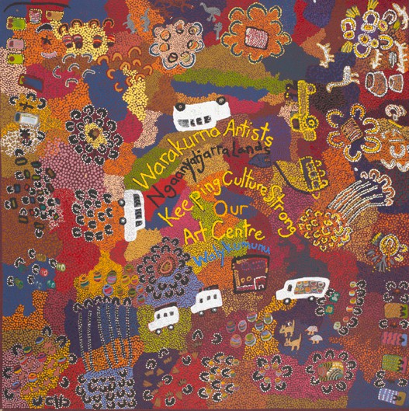

DESCRIPTION | This artwork shows many activities, arts and ceremonies that take place at Warakurna today. What can be seen in this painting is a mix of traditions which have been practised since before Europeans arrived, such as making wooden sculptures and hunting.
WHAT IS IMPORTANT ABOUT THIS ARTWORK | - The activities and images represent a mix of traditional and contemporary interactions. This depicts a strong connection to the location and the relationships between people over time.  - An aerial view has been a cultural interpretation and popular style for many Aboriginal and Torres Strait Islander artists. It can often relate to the Dreaming information which can be overlaid on landscape. This overlay can be physical and spiritual.  - Patterns and/or symbols in Aboriginal and Torres Strait Islander art are a continuation of important cultural stories passed down through generations. It has been a way of storytelling for many years. The use of these patterns or symbols can be seen as an alternative way of writing down stories. Only First Nations people can use these in their storytelling.
ACTIVITY OBJECTIVE | - Use Warakurna resources and discuss artworks.  - Have discussions by asking diverse questions to build cultural understanding.  - Create an artwork to strengthen own knowledge and to build a visual and unique perspective.
DIRECTIONS, QUESTIONS AND IDEAS FOR DELIVERY | - Ask students to look at the artwork Keeping Culture Strong.  - Read the description below and watch video 1.  - Create a safe discussion environment with your class and ask about the different objects in the painting that tell the story. You can also view the artwork in the digital flip book.  - Ask students to write down the objects they can see in the artwork. Questions to prompt conversation could be:  - What is the difference between contemporary and traditional art?  - What contemporary objects can you see? (e.g. cars, words and sleeping bags)  - What First Nations symbols can you see? Such as human symbols and meeting places  - Question: Why do you think these symbols are special to First Nations people?  Answer: Used through generations to represent ceremonies or gatherings  - What colours are used and why do you think the artists used them? Discuss the Warakurna landscape and the colours you may see  - Think and talk about what landmarks and objects you can see from the plane and draw these objects in your artwork together  - Create a safe environment where students can speak about their own community or school and ask questions that create opportunities to discuss the special qualities – the feel it has. Questions to prompt conversation could be:  - What landmarks are important?  - What season is it, and how does it change the colour of the artwork?

c. What natural landscape or man-made areas will be in your drawing?
d. Write down some of the names of the special places you have drawn.
COMPLETING ACTIVITY | STEP 1  Gather your class into small groups and ask students to draw a bird’s eye view of your community or school. Ask students to imagine they are all in a plane, looking over your community or school together as a group.  - The aim is to create comfort as an individual within the group to contribute images in a collaborative artwork.  - Being in a plane could create different views or angles. You may want to sit students on the floor as if they were in a plane.  - Draw objects, landmarks, buildings and streets.  STEP 2  Once the group has completed the artwork ask students to write the First Nations name of the Country they have drawn.  STEP 3  Do you have a street named in First Nations language? If not think of some words that you could name the streets and place on street signs.  STEP 4  This next task requires research. The research itself will be a class activity and does not matter if you cannot find what is requested. The act of looking for and questioning the language origin is what is needed. Discuss how First Nations words have meanings that are different from English words. Often to describe a First Nations word you may need more than one English word.  Ask students to think about other First Nations names for different regions in Australia. In the sky of their artwork or next to some of their special landmarks write down the Aboriginal and or Torres Strait Islander names they know. You may have a park or mountains which are named in First Nations language. Write these names on artwork near landmarks and discuss the meaning of these words.

STEP 5:
It is a national cultural protocol to acknowledge the First Nations land you live on. It is an acknowledgement of the people from this Country and a valued and respectful action.
- Discuss with students the national cultural protocol and ask students if they know how to do an Acknowledgement of Country.
- Write down some words as a group that they think would be in an Acknowledgement of Country.
- You can bring up an acknowledgment from the National Museum of Australia’s Defining Moments Digital Classroom website, found at the bottom of the webpages.

‘The National Museum of Australia acknowledges First Australians and recognises their continuous connection to Country, community and culture.’

