Teacher guide | Year 3

LESSON PREPARATION | Explain the activity to students and encourage them to discuss with family members before undertaking it. Ensure that First Nations students consult with and seek permission from their Elders on aerial artworks and what they mean to them, and seek their permission to draw an aerial artwork before completing the activity.  View the full Warakurna resource on the Digital Classroom website.
DISCUSSING THE ARTWORK AND CULTURAL  CONSIDERATIONS | In your activity you are asked to discuss the below artwork. There are multiple questions provided which help create understanding of cultural expressions to support all modes of delivery. These questions will guide your delivery and support your participants in understanding cultural views of Aboriginal and Torres Strait Islander peoples.  Cultural guidance:  When asking about First Nations symbols in artworks, discuss the cultural significance of Aboriginal symbols and how these symbols originated in Aboriginal artworks. The Aboriginal symbols in this artwork represent Elders doing ceremonies. Ensure students understand that they are Aboriginal interpretations of their Elders and family traditions and ask students how they would represent themselves in their artworks if they are not First Nations people. Ensure you are aware of your students who are First Nations people and provide a safe sharing space that individuals feel confident to express themselves in. Be mindful that not all First Nations people know cultural protocols and symbol origination. Some art styles are owned by certain family groups.
ARTWORK TITLE | Tjanpi
ARTIST | Polly Pawuya Butler-Jackson
ARTWORK IMAGE | 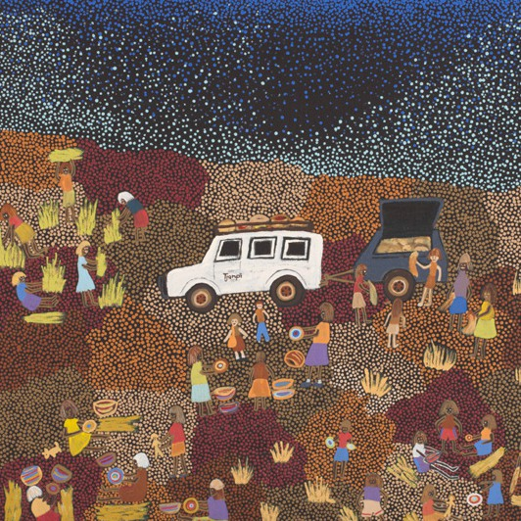

DESCRIPTION | Tjanpi is the word for woven fibre sculptures or objects made from grass and other natural materials. In this painting the artist depicts groups of women working together to collect the grass, dry it and weave it into bowls or sculptures, while telling stories.
WHAT IS IMPORTANT ABOUT THIS ARTWORK | - The activities and images represent a mix of traditional and contemporary interactions. This depicts a strong connection to the location and the relationships between people over time.  - An aerial view has been a cultural interpretation and popular style for many Aboriginal and Torres Strait Islander artists. It can often relate to the Dreaming information which can be overlaid on landscape. This overlay can be physical and spiritual.  - Patterns and/or symbols of Aboriginal and Torres Strait Islander art are a continuation of important cultural stories passed down through generations. It has been a way of storytelling for many years. The use of these patterns or symbols can be seen as an alternative way of writing down stories. Only First Nations people can use these in their storytelling.  - You can view the artwork in digital flip book on pages 20 and 21.
ACTIVITY OBJECTIVE | - Use Warakurna resources and discuss artworks.  - Have discussions by asking diverse questions to build cultural understanding.  - Create an artwork to strengthen own knowledge and to build a visual and unique perspective.  - Play a game that brings diverse perspectives of one shared environment.
DIRECTIONS, QUESTIONS AND IDEAS FOR DELIVERY | - Read through the digital flip book first and use it as a resource to refer to throughout activities. Watch the group activity videos 3 and 4. Discuss the points made below as a group. You may want to split your class up in smaller groups to discuss.  - Question: What are the different meanings of the words ochre and soil?  Answer: Ochre is used by First Nations people in art, ceremonies and sacred ways of living. It is collected in a special way and is found in special areas or regions of the Country. Soil is found everywhere and is not considered as a source of material that is sacred to be used at special times.  - Question: Discuss why you think ochre is different?  Answer: Ochre is used by First Nations people in art, ceremonies and sacred ways of living. It is collected in a special way and is found in special areas or regions of the Country. It is also used traditionally in burial rituals.  - Question: Do First Nations people only tell stories written on the ground?  Answer: Many people over the years and in different countries have done this; however, within Australia First Nations people have told many Dreamtime stories and performed ceremonies written on the ground.

- Question: Discuss why you think the word ochre is used by First Nations people.
Answer: First Nations people often used drawing in sand or soil as a form of teaching people. Some of these stories were sacred and respect must be given around these scenarios. Instead of using dirt or soil it is recommended to use the term ochre. Many of the artworks completed by traditional artists would use ochre colours from the Country about which they told stories.
Today artists still use ochres as an art material. Ochres are primarily natural pigments and minerals found in the soil, or even in charcoal. You can find the meaning of ochre in a general search on the internet. Be sure to use reliable resources such as NMA resources. Some from the ADMDC have been listed below.
- https://digital-classroom.nma.gov.au/images/piece-ochre
- https://digital-classroom.nma.gov.au/images/pieces-red-ochre
- https://digital-classroom.nma.gov.au/images/pieces-yellow-ochre
- https://digital-classroom.nma.gov.au/defining-moments/evidence-first-peoples

- Create a safe environment where a group can discuss the artwork Tjanpi from the Warakurna digital flip book.
  - Discuss why you think it is painted in this landscape view. Look at the colour of the sky and ask what time of the day/night it is.
  - Discuss the name of the artwork and what it means. (Tjanpi is the word for woven fibre sculptures or objects made from grass and other materials for this Warakurna artist.)
  - What objects are in this artwork? Car, trailer, maybe sleeping bags on car roof racks, weaving materials, baskets.
  - What relationship do you think the artist has with the Country? Explain why you think this. The relationship is close, with a great understanding of where weaving materials are collected.
  - What characters are in the artwork? Many women as they are wearing skirts.
  - What do you think the characters are doing? Collecting weaving materials and weaving.

- As a group select an artwork from the Warakurna digital flip book which details an aerial view.
  - Discuss why you think it is an aerial view and why the artist has chosen to do it this way.
  - What objects are in the artwork?
  - What relationship do you think the artist has with the Country? Explain why you think this.
  - What characters are in the artwork and what activities are being completed?

COMPLETING ACTIVITY | STEP 1  Watch both parts of Video 3 to support an understanding within the process of completing an aerial artwork.  STEP 2  Play the ‘Up, down and move around’ game.  STEP 3  Organise groups to draw or paint an aerial view of your school with key characters playing out an activity or activities.  STEP 4  Discuss what activities are in the artwork, what time of year it is and the objects in the artwork.  STEP 5  It is important to develop a playful learning style when assessing knowledge learnt. Complete ‘Up, down and move around’ game and grid game to gather knowledge learnt.

