[title]

Teacher guide | Year 4

LESSON PREPARATION | Explain the activity to students and encourage them to discuss with family members before undertaking it. Ensure that First Nations students consult with and seek permission from their Elders on aerial artworks and what they mean, and seek their permission to draw an aerial artwork before completing the activity.  View the full Warakurna resource on the Digital Classroom website.
DISCUSSING THE ARTWORK AND CULTURAL  CONSIDERATIONS | In your activity you are asked to discuss the below artwork. There are multiple questions provided which help create understanding of cultural expressions to support all modes of delivery. These questions will guide your delivery and support your participants in understanding cultural views of Aboriginal and Torres Strait Islander peoples.  Cultural guidance:  When asking about First Nations Symbols in artworks, discuss the cultural significance of Aboriginal symbols and how these symbols originated in Aboriginal artworks. The Aboriginal symbols in this artwork represent Elders doing ceremonies. Ensure students understand that they are Aboriginal interpretations of their Elders and family traditions and ask students how they would represent themselves in their artworks if they are not First Nations people. Ensure you are aware of your students who are First Nations people and provide a safe sharing space that individuals feel confident to express themselves in. Be mindful that not all First Nations people know cultural protocols and symbol origination. Some art styles are owned by certain family groups.  Research:  Ball sports are popular all over the world and some people believe this type of football game originated from First Nations people. Look at types of balls produced by First Nations people and/or other games.
ARTWORK 1 TITLE | Tjanpi
ARTIST | Polly Pawuya Butler-Jackson

ARTWORK IMAGE | 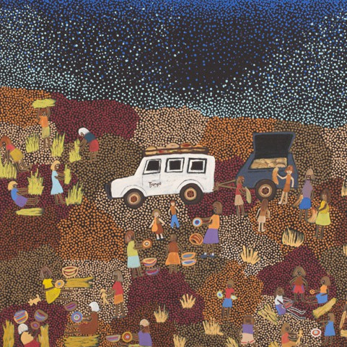
DESCRIPTION | Tjanpi is the word for woven fibre sculptures or objects made from grass and other natural materials.  In this painting the artist depicts groups of women working together to collect the grass, dry it and weave it into bowls or sculptures, while telling stories.
WHAT IS IMPORTANT ABOUT THIS ARTWORK | - The activities and images represent a mix of traditional and contemporary interactions. This depicts a strong connection to the location and the relationships between people over time.  - An aerial view has been a cultural interpretation and popular style for many Aboriginal and Torres Strait Islander artists. It can often relate to the Dreaming information which can be overlaid on landscape. This overlay can be physical and spiritual.  - Patterns and/or symbols of Aboriginal and Torres Strait Islander art are a continuation of important cultural stories passed down through generations. It has been a way of storytelling for many years. The use of these patterns or symbols can be seen as an alternative way of writing down stories. Only First Nations people can use these ways of using images of storytelling.
ARTWORK 2 TITLE | Warakurna Kangaroos and Warburton Tigers, 2012
ARTIST | Rocky Porter
ARTWORK IMAGE | 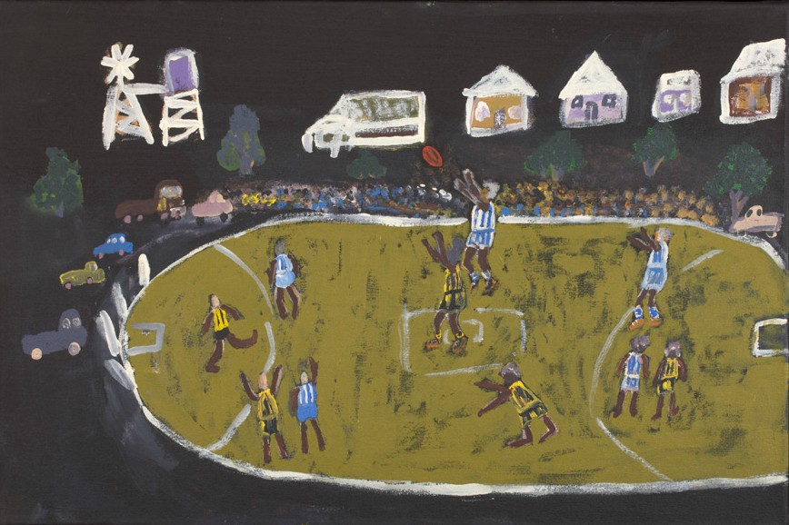

DESCRIPTION | This painting by Rocky Porter shows two teams playing Aussie Rules at the oval in Warakurna. Many people believe that some rules for AFL came from an Aboriginal game called Marngrook.
WHAT IS IMPORTANT ABOUT THIS ARTWORK | - The activities and images represent a mix of traditional and contemporary interactions. This depicts a strong connection to the location and the relationships between people over time.  - An aerial view has been a cultural interpretation and popular style for many Aboriginal and Torres Strait Islander artists. It can often relate to the Dreaming information which can be overlaid on landscape. This overlay can be physical and spiritual. This contemporary artwork from this view suggests a continuity in cultural beliefs through visual representation.
ACTIVITY OBJECTIVE | - Use Warakurna resources and discuss artworks.  - Research an object, providing image source.  - Have discussions by asking diverse questions to build cultural understanding.  - Create an artwork to strengthen own knowledge and to build a visual and unique perspective.  - Play ‘Up, down and move around’ game to change perspective.  - Create a short poem.
DIRECTIONS, QUESTIONS AND IDEAS FOR DELIVERY | - Create a safe environment where groups can discuss and complete activities. Each group can read through the flip book and choose two artworks they think are similar. Once they have chosen the artworks ask groups to explain to the class why they think they are similar. Support writing findings. Similarities could be:  - activities be carried out  - the artist descriptions  - colours being used which determine the location of Country  - patterns and symbols that certify First Nations art  - words used.  - Watch the group activity videos 3 and 4 and discuss the points made below as a group.  - Question: What are the different meanings of the words ochre and soil?  Answer: Ochre.  - Question: Discuss why you think ochre is different from soil.  Answer: First Nations people often used drawing in sand or soil as a form of teaching people. Some of these stories were sacred and respect must be given around these scenarios. Instead of using dirt or soil it is recommended to use the term ochre. Many of the artworks completed by traditional artists would use ochre colours from the Country about which they told stories.

Today artists still use ochres as an art material. Ochres are primarily natural pigments and minerals found in the soil, or even in charcoal. You can find the meaning of ochre in a general search on the internet. Be sure to use reliable resources such as NMA resources. Some from the ADMDC have been listed below.
- https://digital-classroom.nma.gov.au/images/piece-ochre
- https://digital-classroom.nma.gov.au/images/pieces-red-ochre
- https://digital-classroom.nma.gov.au/images/pieces-yellow-ochre
- https://digital-classroom.nma.gov.au/defining-moments/evidence-first-peoples

- Question: What do First Nations people use ochre for?
Answer: Body painting in ceremonies, artworks and sacred business.

- Research ochre and discuss one image you have found that tells you a little more about ochre and how it is used. Reference where you found this information and present to your class. Print an image of ochre and stick in the activity booklet referencing resource.
- Part 1
Research a First Nations Australian poet and look at the words they use to help you imagine and feel what they are saying. Ask students to complete the activity booklet answering below questions:
  - First Nations poet
  - the poem they wrote
  - words you like in the poem.
Part 2
Choose one of the below artworks from the Warakurna flip book and write a poem about how it makes you feel.

Artwork 1 Artwork 2

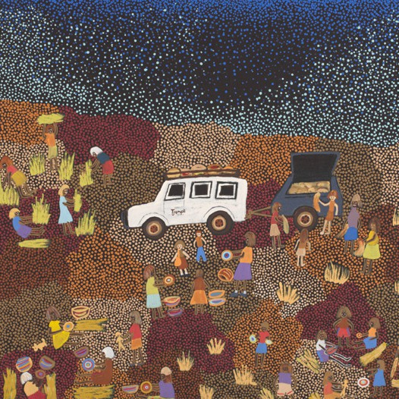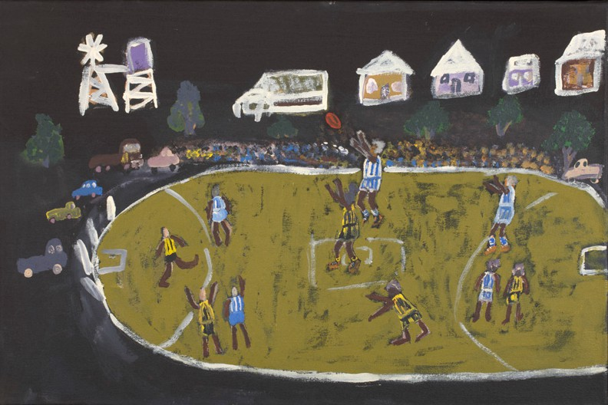

COMPLETING ACTIVITY | - Ask students to complete My poem and First Nations art in activity booklet.  - Play the ‘Up, down and move around’ game outside in your school playground. Ask students/players to remember one word of an object, landmark, building or feeling that they experienced in this game.  Ensure students write the word down in activity booklet.  - In a group, draw or paint an aerial view of your school playground with key characters playing out an activity. Write a short poem together that accompanies your artwork.  Note: Students must use the one word they collected from the game in this poem. The other players in the group must also use the words they saved in this game.  For example:  Alice’s word word – grass. Charles’s word – running.  Group poem:  We love running fast on the playground grass.  It is important to develop a playful learning style when assessing knowledge learnt. Complete ‘Up, down move around’ game to gather knowledge learnt.

