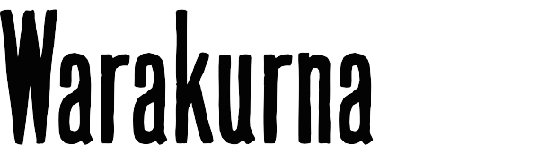

Teacher guide | Year 6

LESSON PREPARATION | This activity requires investigating the Warakurna: All the stories got into our minds and eyes educational resource package on the Australia’s Defining Moments Digital Classroom. As there are many diverse information styles available, the Museum suggests you create opportunities for students to involve family for some research components to strengthen engagement beyond the classroom.  The last year of primary school requires innovative learning methods to prepare students for secondary school. To support this learning journey, the Museum has created activities that foster healthy conversations for learners and enable them to select and organise ideas. Having conversations with family members will assist students to form their own opinions as well as developing diversity within the classroom.  Explain the activity to students and encourage them to discuss with family members before the activity is to be completed. Ensure that First Nations students consult with and seek permission from their Elders before completing the activity.
ACTIVITY 1 | Resources: https://digital-classroom.nma.gov.au/warakurna  View the Warakurna resources listed below and create a document that will lead students in taking notes on how the sources of information regarding the same imagery can have a different effect on understanding the artworks.  - About page  - Digital flip book  - Artworks  - Artists  - Audio and videos  You may use the student activity booklet resource provided or points to consider when creating your own tailored document:  - Which resource gave you more knowledge and why?  - What characteristics in your favourite artwork/images created the most impact and presented individuality?  Cultural considerations  The way that First Nations people express generational knowledge and pass on stories is unique in memory storing. The characters they use and the style of storytelling embeds knowledge in a practical way of learning. Being, doing and knowing is a key element in cultural practices. How does the Museum deliver cultural products to community so that messages within artworks are not lost in translation?

ARTWORK TITLES | Any artworks from the Warakurna: All the stories got into our minds and eyes resource. Please refer to the artworks section and/or the flip book. An example was provided in the student activity booklet: Keeping Culture Strong, 2008
ARTISTS | All artists from the Warakurna: All the stories got into our minds and eyes resource. Please refer to the artists section and/or the flip book. An example was provided in the student activity booklet: Keeping Culture Strong, 2008 was painted by 6 artists.  Artists: Eunice Yunurupa Porter, Molly Malungka Yates, Judith Yinyika Chambers, Anna Porter, Maisie Nungurrayi Ward and Polly Pawuya Butler-Jackson.
ARTWORK IMAGE | 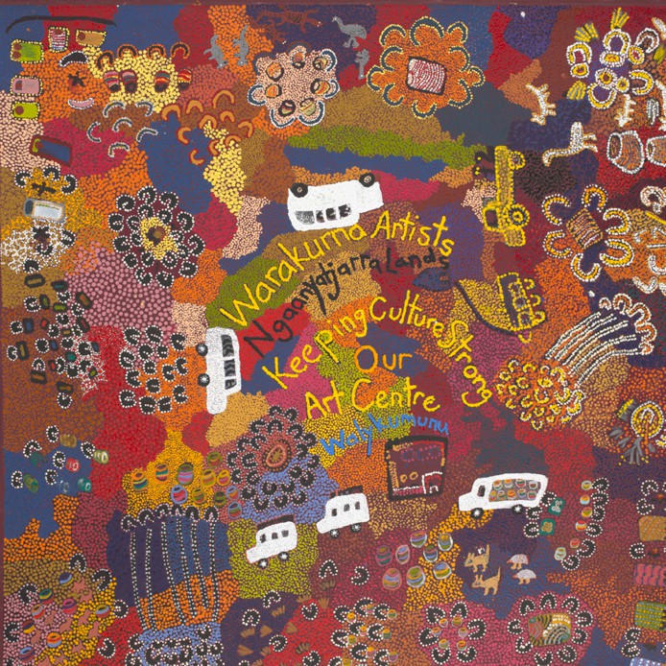
DESCRIPTION | The paintings and sculptures from the Western Desert community of Warakurna recreate scenes of everyday life and tell historical and contemporary stories. The artworks that fill the pages of the flip book resource were first featured in Warakurna: All the Stories Got into our Minds and Eyes, an exhibition originally displayed at the National Museum of Australia, Canberra, in 2012–13.
WHAT IS IMPORTANT ABOUT THIS ARTWORK | - The activities and images represent a mix of traditional and contemporary interactions. This depicts a strong connection to the location and the relationships between people over time.  - Aerial views are a cultural interpretation and popular style for many Aboriginal and Torres Strait Islander artists. They can often relate to Dreaming information which can be overlaid on landscape. This overlay can be physical and spiritual.  - Patterns and/or symbols of Aboriginal and Torres Strait Islander art are a continuation of important cultural stories passed down through generations. It has been a way of storytelling for many years. The use of these patterns or symbols can be seen as an alternative way of writing down stories. Only First Nations people can use these for storytelling.

ACTIVITY OBJECTIVE | - Use Warakurna resources and discuss artworks.  - Have discussions by asking diverse questions to build cultural understanding.  - Create an artwork to strengthen own knowledge and to build a visual and unique perspective.  - Create a short poem.
DIRECTIONS, QUESTIONS AND IDEAS FOR DELIVERY | - Ask students to choose an artwork from the Warakurna artworks section and write 30 to 50 words on:  - how this artwork created a deeper cultural understanding in Indigenous connection to Country or place for them  - how the artist created a style that was unique  - how did this style express their emotions or knowledge  - which characters played a major role in the storyline of the artwork.  Cultural guidance:  When asking about First Nations Symbols in artworks, discuss the cultural significance of Aboriginal symbols and how these symbols originated in Aboriginal artworks. The Aboriginal symbols in this artwork represent Elders doing ceremonies. Ensure students understand that they are Aboriginal interpretations of their Elders and family traditions and ask students how they would represent themselves in their artworks if they are not First Nations people. Ensure you are aware of your students who are First Nations people and provide a safe sharing space that individuals feel confident to express themselves in. Be mindful that not all First Nations people know cultural protocols and symbol origination. Some art styles are owned by certain family groups.  Create time for groups to choose an artwork from their favourite resource and explain to the class/other groups how they think this resource best suited the image and was able to express its meaning. Points to address are historical, social and cultural.
COMPLETING ACTIVITY | STEP 1:  As a class, watch videos and split class into groups to complete an aerial view artwork of your town or a region of your city. The artworks must display a historical or social event that has impacted the chosen location. Ask each student to write a description of their group artwork explaining the elements in collaborative artwork that are historical or social.  Points to consider when creating your artwork:  - Images used  - Themes of events or era  - Language you may place in your artwork to support a theme, place or era/time.

STEP 2:
It is important to develop a playful learning style when assessing knowledge learnt. Complete grid game to gather knowledge learnt.
- Encourage students to make rhymes for their questions in gathering and joining coordinates in grid game.

