Teacher guide: Deep time | Year 7

LESSON PREPARATION | This activity requires investigating the Warakurna: All the stories got into our minds and eyes educational resource package on the Australia’s Defining Moments Digital Classroom. As there are many diverse information styles available, the Museum suggests you create opportunities for students to involve family for some research components to strengthen engagement beyond the classroom.  As learners are more independent, self-reliant and self-motivated in the first year of high school, they require activities that will push thinking boundaries and validate their inner confidence. The Museum’s activities have been designed with the deep time curriculum to investigate new ways of thinking within history.  Explain the activity to students and encourage them to discuss with family members before the activity is to be completed. Ensure that First Nations students consult with and seek permission from their Elders before completing the activity.
DISCUSSING THE ARTWORK AND CULTURAL  CONSIDERATIONS | Resources: https://digital-classroom.nma.gov.au/warakurna  - Make time to view the Warakurna resources listed below and ask students to take notes on how these sources of information regarding the same imagery can have a different effect on how the viewer could understand or feel about those images when presented in different ways.  - Flip book  - Videos  - Artworks  - Artists  Points to consider when inspiring note taking:  - Which resource gave you more knowledge and why?  - What characteristics in your favourite artwork/images created the most impact and presented individuality?  - If a viewer only saw the artwork from the flip book and did not see the ADMDC Artworks section, do you think the viewer would still get a good understanding of what the artwork was about?  Cultural considerations:  The way that First Nations people express generational knowledge and pass on stories is unique in memory storing. The characters they use and the style of storytelling embeds knowledge in a practical way of learning. Being, doing and knowing is a key element

 | in cultural practices. How does the Museum deliver cultural products to community so that messages within artworks are not lost in translation?
ARTWORK TITLE | Land Management, Burning Country, 2012
ARTIST | Dianne Ungukalpi Golding
ARTWORK IMAGE | 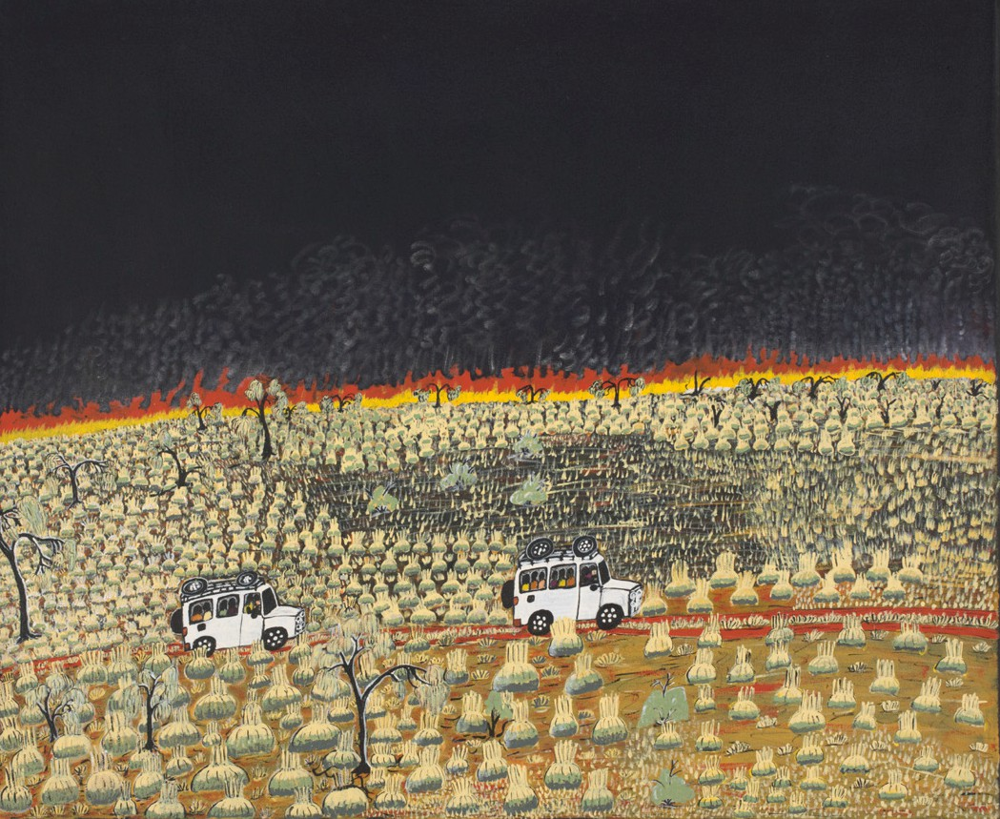
DESCRIPTION | First Nations people have been caring for Country for thousands of years. In this painting, the artist shows how to care for Country with a controlled burn or fire. You can see the flames in the background. These fires burn old and dry grass. They are only lit when the weather is cooler and only when there is a light wind. This practice both helps prevent big bushfires and lets new grass grow, bringing wildlife to the area.
WHAT IS IMPORTANT ABOUT THIS ARTWORK | - The activities and images represent a mix of traditional and contemporary interactions. This depicts a strong connection to the location and the relationships between people and cultural practices over a period of time.  - Aerial views are a cultural interpretation and popular style for many Aboriginal and Torres Strait Islander artists. It can often be related to the Dreaming information which can be overlaid on landscape. This overlay can be physical and spiritual.  - Aboriginal and Torres Strait Islander art is a continuation of important cultural stories passed down through generations. Art has been a way of storytelling for many years and can be seen as an alternative way of writing down stories. First Nations people have been using art for storytelling and cultural practice sharing for thousands of years.

ARTWORK TITLE | Tjanpi, 2011
ARTIST | Polly Pawuya Butler-Jackson
ARTWORK IMAGE | 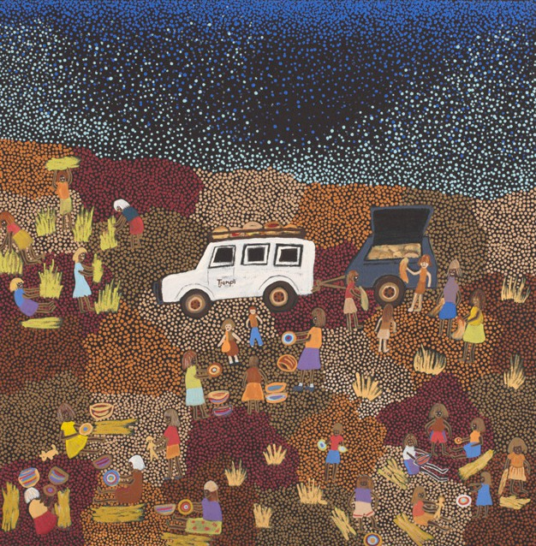
DESCRIPTION | Tjanpi is the word for woven fibre sculptures or objects made from grass and other natural materials.  Those who work at the Warakurna Art Centre know how to make these sculptures using materials from the land.  Polly Butler-Jackson was born at Yulpigari and has been making grass and fibre baskets and sculptures for many years. In this painting she depicts groups of women working together to collect the grass, dry it and weave it into bowls or sculptures, while telling stories.  Younger girls learn the art of tjanpi from their mothers and grandmothers.
ACTIVITY OBJECTIVE | - Use Warakurna resources and discuss artworks.  - Have discussions by asking diverse questions to build cultural understanding.  - Create an artwork to strengthen own knowledge and to build a visual and unique perspective.  - Create a short poem.
DIRECTIONS, QUESTIONS AND IDEAS FOR DELIVERY | - View the artwork Land Management, Burning Country, 2012, and discuss the ideas and different regions that practice this act of caring for Country.  Be sure to use reliable resources such as the National Museum of Australia. Some have been listed below from the website:  - https://www.nma.gov.au/  - https://www.nma.gov.au/exhibitions/on-country/burn-off  - https://www.nma.gov.au/explore/collection/highlights/martumili-ngurra-canvas

Points to talk about:
- How can you tell it is a cultural burn?
- What would happen if cultural burns were not conducted?
- How has the artist captured this point of view in images?
- What images, scale and colours help tell the story?
- Do all First Nations groups complete cultural burns?
Deep time
DIRECTIONS, QUESTIONS AND IDEAS FOR DELIVERY | - This activity requires you to research and understand the First Nations practice of cultural burns. In doing this, you will build an understanding of generational knowledge transfer on Country. Investigate the artwork Land Management, Burning Country, 2012 in the Warakurna resource as well as one or two additional resources on cultural burns.  From your findings write 100–200 words answering the below questions.  - What do you think generational knowledge transfer is when referring to cultural practices performed by First Nations people on Country and how do you think it is relevant to cultural burns?  - What do you think prompted First Nations people to carry out cultural burns?  - How does a cultural burn affect the Country?  - What regions of Australia would need to do a cultural burn and why?  - What could happen if a cultural burn was not conducted?  - In the artwork Land Management, Burning Country, 2012, aside from the title, how can you tell t it is a cultural burn?  Cultural guidance:  Many national parks have First Nations groups which complete these cultural practices in daily business. Researching these organisations can be a great starting point. Create time for groups to choose resources and explain to the class/other groups how they think this resource best reflected the cultural burning practice and was able to express its meaning.  - Find other image evidence that First Nations people have continued the cultural burn practice of land management into today’s ways of living. Present to your class explaining what images you found and what characters or elements detail this cultural practice.

Points to consider:
- Your evidence images display continuity and change in this cultural practice. You may have primary and secondary sources of historical evidence.
- Find diverse images showing technique, tools and resources used for cultural burning.
- View the artwork Tjanpi and read the description in flip book on the Artwork section of website. Discuss with class colleagues or in groups how the activities performed in this artwork would contribute to gained knowledge of the Country.

Points to consider:
- Would collecting materials from the land give a better understanding of when, how and where they grow?
- In what way would using materials from the land develop knowledge on seasons of the Country?
- Can you think of materials you have used from the land? Describe what they are and how you have used them.
- How do you think a cultural burn would be done on the Country depicted in the artwork?
- Who do you think would give advice on completing a cultural burn on this Country and why?
COMPLETING ACTIVITY | STEP 1:  Watch both parts of video 3 – National Museum art activity and complete in a group two aerial artworks of your town or city before there were any buildings  Artwork 1: Before a cultural burn  Artwork 2: During or after a cultural burn  Write a description explaining what the landscape is and why you would have a cultural burn where you have placed it. Be sure to brainstorm with your group ideas of historical, social and cultural themes of the landscape and display these in your artwork. Be innovative with the material you use to create these artworks.  Resources which will support your knowledge growth:  - https://www.nma.gov.au/audio/defining-moments-in-australian-history/defining-moments-fire  - https://www.nma.gov.au/exhibitions/papunya-painting/educational-resources/dreaming-story-warlugulong

Points to consider when creating your artwork:
- Images used
- Themes of events or era
- Language you may place in your artwork to support a theme, place, or era/time.

STEP 2:
It is important to develop a playful learning style when assessing knowledge learnt. Complete grid game to gather knowledge learnt.
- Encourage students to use historical dates of natural events where possible for their questions in gathering and joining coordinates in grid game.

