Student activity booklet: Deep time | Year 7

Resources: https://digital-classroom.nma.gov.au/warakurna

- This activity requires you to research and understand the First Nations practice of cultural burns. In doing this, you will build an understanding of generational knowledge transfer on Country. Investigate the artwork Land Management, Burning Country, 2012 in the Warakurna resource as well as one or two additional resources on cultural burns. From your findings write 100–300 words answering the below questions.

  - What do you think generational knowledge transfer is when referring to cultural practices performed by First Nations people on Country and how do you think it is relevant to cultural burns?
  - What do you think prompted First Nations people to carry out cultural burns?
  - How does a cultural burn affect the Country?
  - What regions of Australia would need to do a cultural burn and why?
  - What could happen if a cultural burn was not conducted?
  - In the artwork Land Management, Burning Country, aside from the title, how can you tell it is a cultural burn?

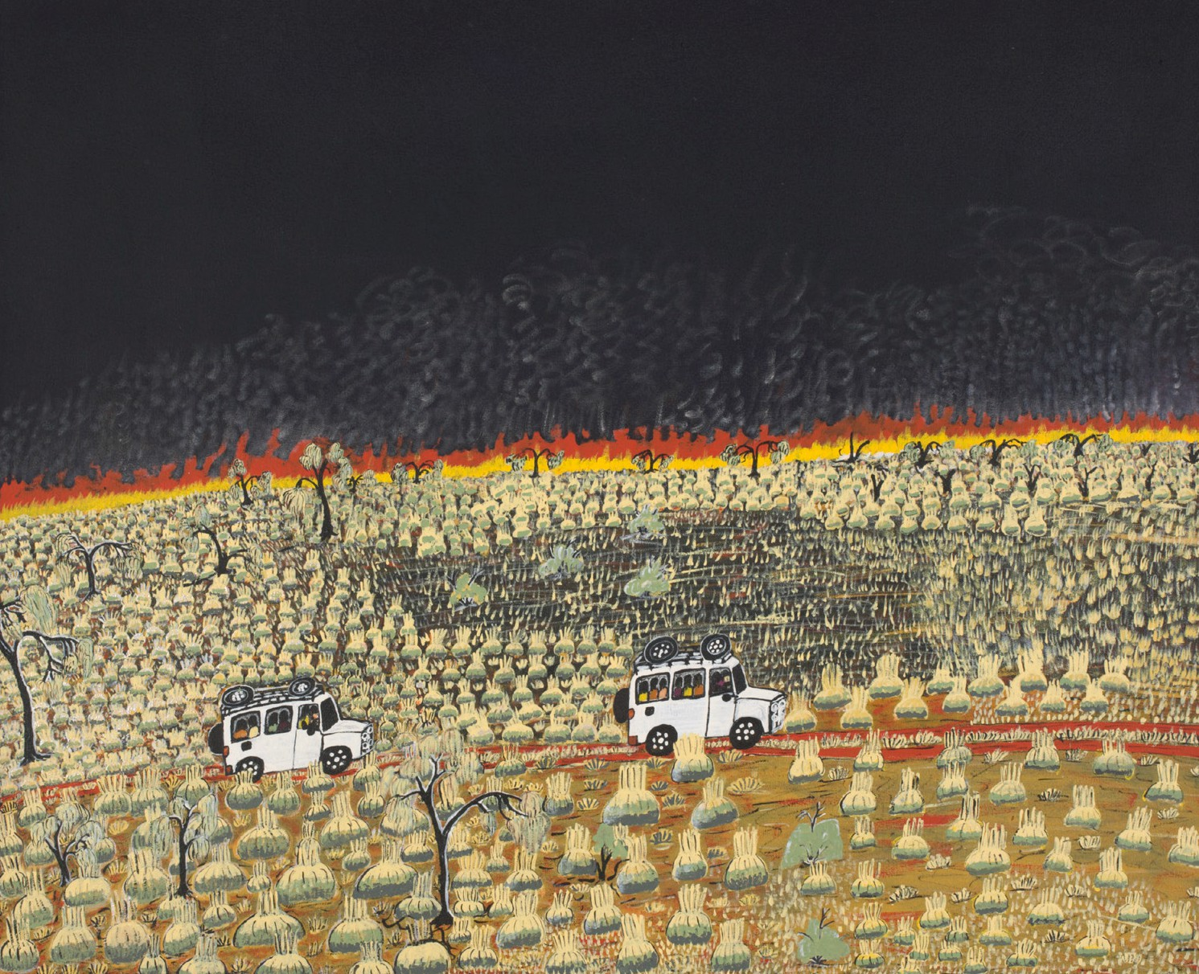
Land Management, Burning Country, 2012

- Find other image evidence that First Nations people have continued the cultural burn practice of land management into today’s ways of living. Present to your class explaining what images you found and what characters or elements detail this cultural practice.

Points to consider:

  - Your image evidence should display continuity and change in this cultural practice. You may have primary and secondary sources of historical evidence.
  - Find diverse images showing technique, tools and resources used for cultural burning.

- View the artwork Tjanpi and read the description in the digital flip book on the Artwork section of the website. Discuss with class members or in groups how the activities performed in this artwork would contribute to gaining knowledge of the Country.

Points to consider:

  - Would collecting materials from the land give a better understanding of when, how and where they grow?
  - In what way would using materials from the land develop knowledge on seasons of the Country?
  - Can you think of materials you have used from the land? Describe what they are and how you have used them.
  - How do you think a cultural burn would be done on the Country depicted in the artwork?
  - Who do you think would give advice on completing a cultural burn on this
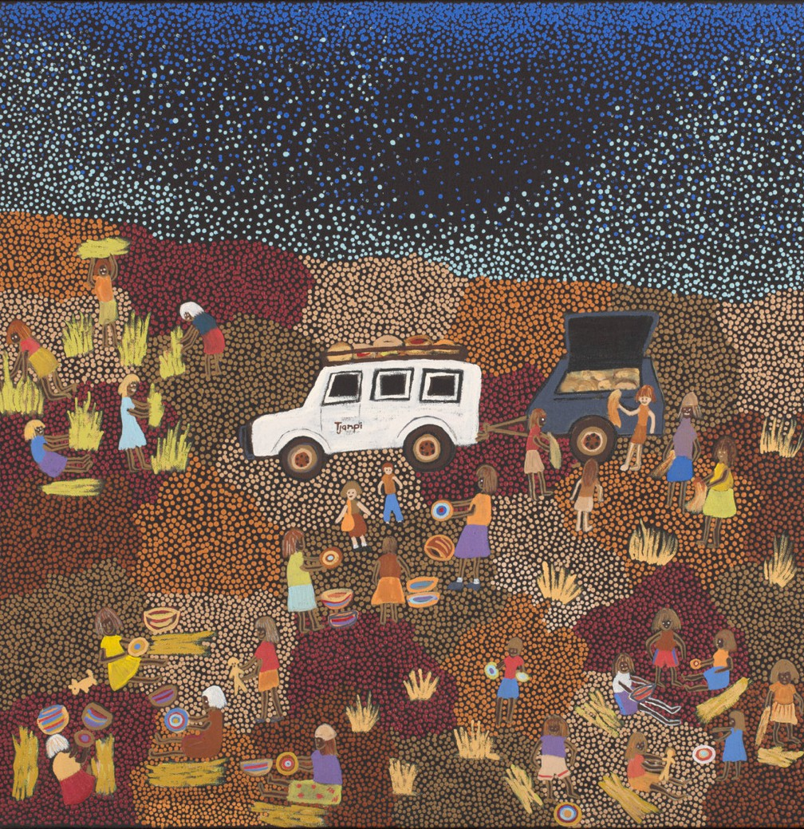
Tjanpi, 2011 | Artist: Dianne Ungukalpi Golding

Country and why?
- Watch video 3 and complete in a group two aerial artworks of your town or city before there were any buildings.

Artwork 1: Before a cultural burn
Artwork 2: During or after a cultural burn

Write a description explaining what the landscape is and why you would have a cultural burn where you have placed it.

Be sure to brainstorm with your group ideas of historical, social and cultural themes of the landscape and display these in your artwork. Be innovative with the material you use to create these artworks.

Resources which will support your knowledge growth:

  - https://www.nma.gov.au/audio/defining-moments-in-australian-history/ defining-moments-fire
  - https://www.nma.gov.au/exhibitions/papunya-painting/educational-resources/ dreaming-story-warlugulong

- It is important to develop a playful learning style when assessing knowledge learnt. Complete the grid game to gather knowledge learnt.

Use historical dates of natural events where possible for your questions when gathering and joining coordinates in the grid game.

