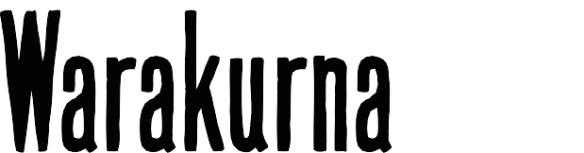

Student activity booklet | Year 7

Resources: https://digital-classroom.nma.gov.au/warakurna

- View the Warakurna resources listed below and take notes on how these sources of information using the same imagery can have a different effect on how you understand or feel about those images when presented in different ways.

  - Videos 1 and 2
  - Flip book
  - Artworks
  - Artists

Points to consider when taking notes:

  - Which resource gave you more knowledge and why?
  - What characteristics in your favourite artwork/images created the most impact and presented individuality?

- View the artwork Land Management, Burning Country, 2012, and discuss the ideas and different regions that practice this act of caring for Country.
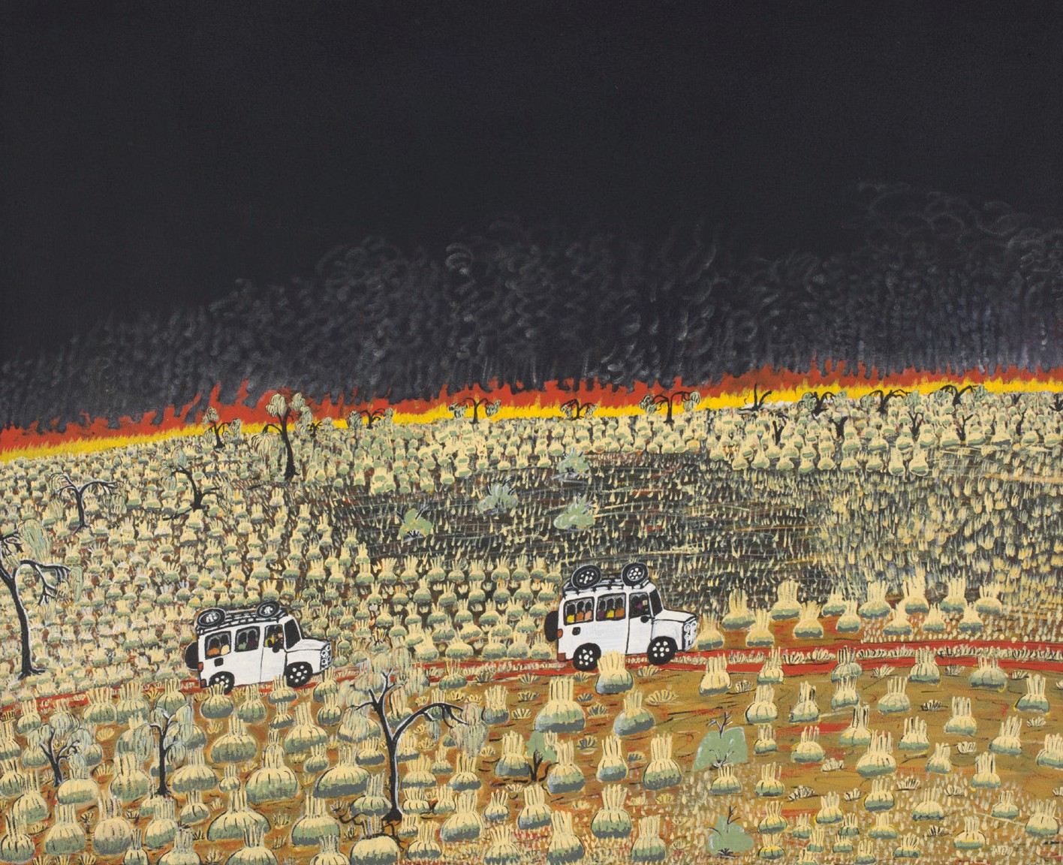
Land Management, Burning Country, 2012

Be sure to use reliable resources such as the National Museum of Australia. Some have been listed below from the website:

  - https://www.nma.gov.au/
  - https://www.nma.gov.au/exhibitions/on-country/burn-off
  - https://www.nma.gov.au/explore/collection/highlights/martumili-ngurra-canvas

Points to talk about:

  - How can you tell it is a cultural burn?
  - What would happen if cultural burns were not conducted?
  - How has the artist captured this point of view in images?
  - Do all First Nations groups complete cultural burns?

